For each of the following linear relationships:
- Write the rule
- Draw the graph
Question 1
x | -2 | -1 | 0 | 1 | 2 | 3 | 4
y | 0 | 2 | 4 | 6 | 8 | 10 | 12
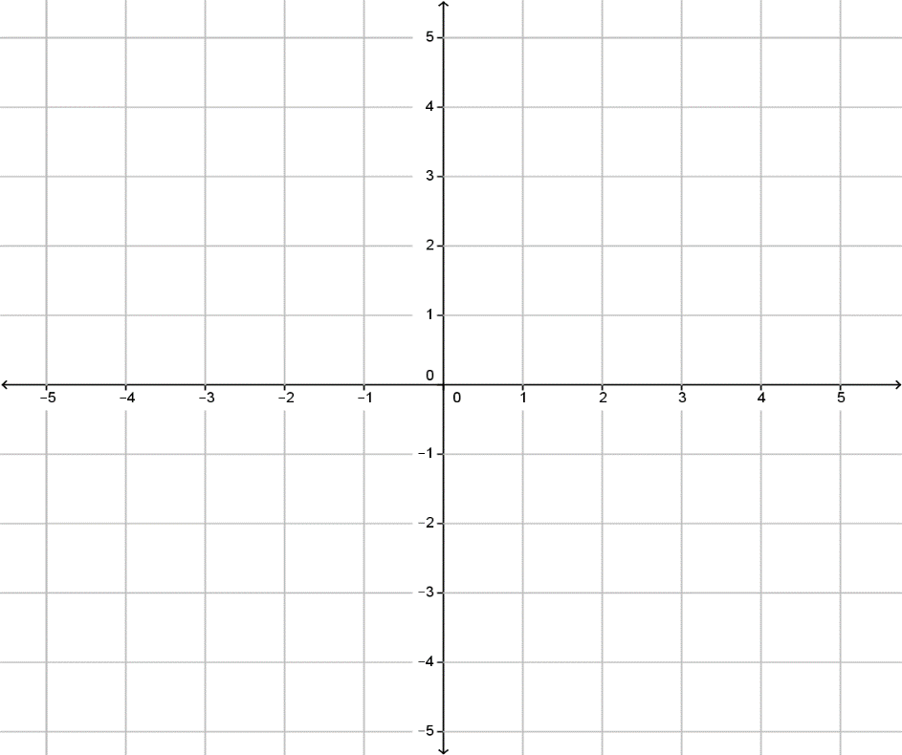
y
$$y$$
$$x$$
Gradient =
y- intercept =
Therefore the rule is
y = ____ x + _____

x

Question 2
x | -2 | -1 | 0 | 1 | 2 | 3 | 4
y | -4 | -3 | -2 | -1 | 0 | 1 | 2

y
$$y$$
$$x$$
Gradient =
y- intercept =
Therefore the rule is
y = ____ x + _____

x

Q3) On the graph below, draw the following equations.

$$y$$
$$x$$
$y = 3x – 1$

$y = -4x +3$

$y = -2x$


$$y$$
$$x$$

Q3) On the graph below, draw the following equations.

$y = 3x – 1$

$y = -4x +3$

$y = -2x$

Q1) Complete the table using the linear equation $y= x+6$

$$x$$ | -1 | 0 | 1 | 2 | 3
$$y$$

Q2) Write the equation for the following table _____________________________

$$x$$ | -1 | 0 | 1 | 2 | 3
$$y$$ | 7 | 4 | 1 | -2 | -5

Q1) Complete the table using the linear equation $y= x+6$

$$x$$ | -1 | 0 | 1 | 2 | 3
$$y$$

Q2) Write the equation for the following table _____________________________

$$x$$ | -1 | 0 | 1 | 2 | 3
$$y$$ | 7 | 4 | 1 | -2 | -5

